39. Vehicle Detection in a Video Frame Using OpenCV
Aim
To detect vehicles in a video using OpenCV and a pre-trained YOLO object detection model.
Algorithm
- Import OpenCV and YOLO libraries.
- Load the pre-trained YOLO model.
- Open the input video.
- Read the video frame by frame.
- Detect objects in each frame.
- Identify vehicles such as car, bus, truck, and motorcycle.
- Draw bounding boxes around detected vehicles.
- Display the output video.
- Press q to stop the video.
- Release the video and close all windows.
Python Program
from ultralytics import YOLO
import cv2
# Load YOLO model
model = YOLO("yolo11n.pt")
# Open video
cap = cv2.VideoCapture("vehicle.mp4")
vehicle_classes = ["car", "motorcycle", "bus", "truck"]
while True:
ret, frame = cap.read()
if not ret
break
# Detect objects
results = model(frame)
# Process detections
for result in results:
boxes = result.boxes
for box in boxes:
class_id = int(box.cls[0])
confidence = float(box.conf[0])
label = model.names[class_id]
if label in vehicle_classes and confidence > 0.5:
x1, y1, x2, y2 = map(int, box.xyxy[0])
# Draw bounding box
cv2.rectangle(
frame,
(x1, y1),
(x2, y2),
(0, 255, 0),
2
cv2.putText(
frame,
f"{label} {confidence:.2f}",
(x1, y1 - 10),
cv2.FONT_HERSHEY_SIMPLEX,
0.6,
(0, 255, 0),
2
)
# Display frame
cv2.imshow("Vehicle Detection", frame)
# Press q to exit
if cv2.waitKey(1) & 0xFF == ord("q"):
break
# Release resources
cap.release()
cv2.destroyAllWindows()
Output
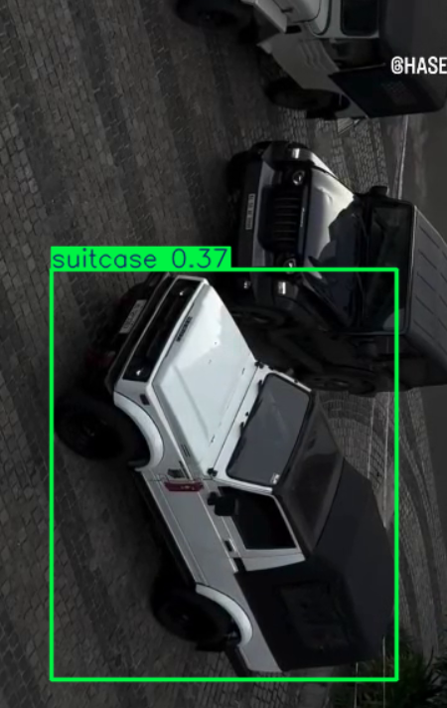
Result
Thus, vehicles such as cars, motorcycles, buses, and trucks were successfully detected in the video using OpenCV and YOLO object detection.

